Galaxy Donuts: Finding the Optimal Location for a New Donut Shop in Minneapolis, MN

By: Jonathan Sipola

October 21, 2019

1. Introduction

1.1. Background

I represent a national donut shop, Galaxy Donuts, and we are expanding into the state of Minnesota. Our focus is on finding a location in the city of Minneapolis that will maximize profitability for the company. The biggest problem identified by our new CEO is our donut competition has been established for some time in the Minneapolis area. However, based on a preliminary analysis, we know there is room for at least one location for our brand.

We will need to analyze the 83 neighborhoods of the city of Minneapolis, and make the decision based on optimal distance from location of competitor donut shops in and around Minneapolis. We also want to place our store in a neighborhood with a low crime rate. High median household income in the neighborhood is critical to our success as a premium brand. And finally, we want to place the location of our stores in higher density areas that will ensure plenty of traffic, as well as have other activities for our customers to do after they have their minds blown by our donuts.

1.2 The Data

I will be using the Foursquare API to identify all donut shops in and around the city of Minneapolis. These will be indicated with red donuts on the map I create. Next, I will determine which neighborhoods are the optimal/maximal distance from the other donut shops.

Once I have that list of neighborhoods, I will analyze those specific neighborhoods, dividing out all residential and industrial space, leaving only commercial space. I will also map the crime rate by neighborhood. To do this, I will utilize city of Minneapolis open source data from <http://opendata.minneapolismn.gov/> to help with this determination. I will also use city of Minneapolis open source data to calculate the population of each candidate neighborhood as well as the median income of a household.

The final work product will be a map of Minneapolis, linked to the Foursquare API denoting all competitors, and I will use all the data discussed above to place the coveted blue donut where Galaxy Donuts will open its newest location in Minneapolis. All the findings will be returned in a formatted report with visuals and a pdf of the slides from a PowerPoint presentation. I will also write the computer program used for analysis in a Jupyter Notebook and share it on my Github page with my colleagues.

2. Methodology

2.1 Foursquare API

First, I called the Foursquare API and inputted the specific requirement to return all donut shops in the Minneapolis area of Minnesota. Here is a sample of what was returned:

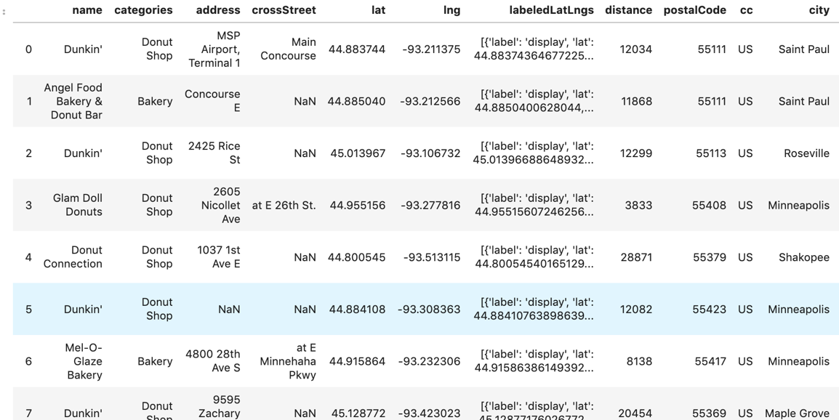

Next, I cleaned the data, because there were locations that were obviously mislabeled, and I made sure all of the geographical data were accurate. The final list contained 25 donut competitors in and around Minneapolis:

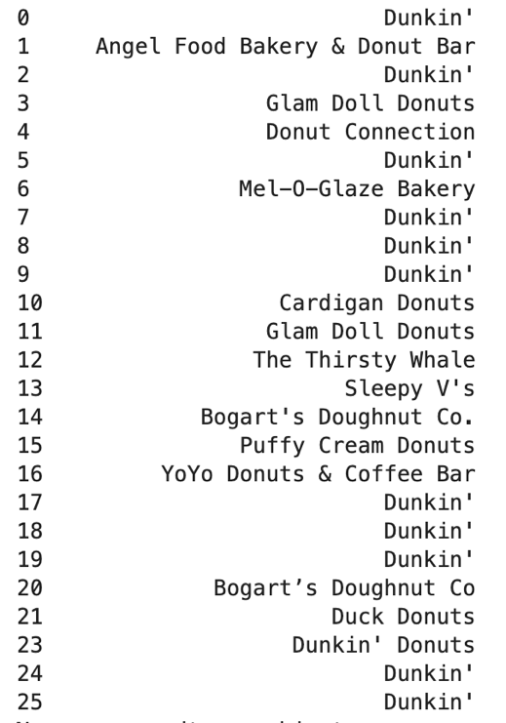

2.2 Folium

I used Folium to combine a GeoJson file from <http://opendata.minneapolismn.gov/> that mapped all 83 distinct Minneapolis neighborhoods, with the Foursquare API donut shop data

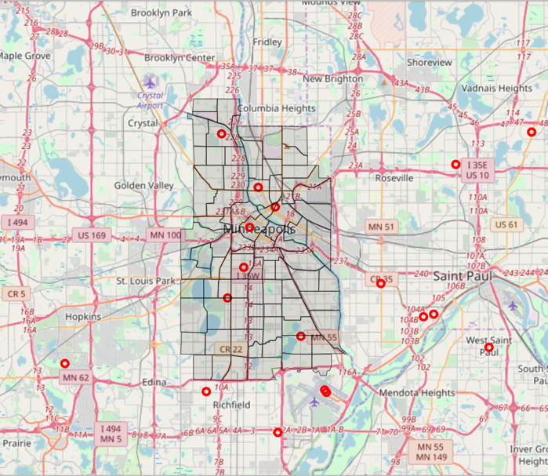

to create a map that overlays all existing donut shops (red donuts) over the city of Minneapolis, divided into neighborhoods.

2.3 Crime Data

I created a data frame using a csv file from <http://opendata.minneapolismn.gov/> of crime by neighborhood in Minneapolis.

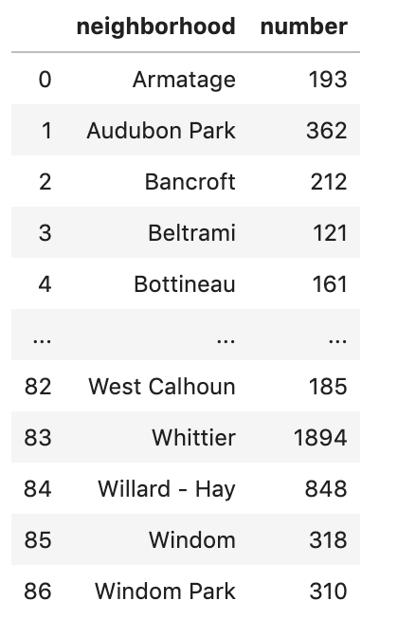

I was then able to create a second map of Minneapolis, but this one was a choropleth where the rate of crime is visually depicted by a “Yellow, Orange, Red” color gradient by neighborhood.

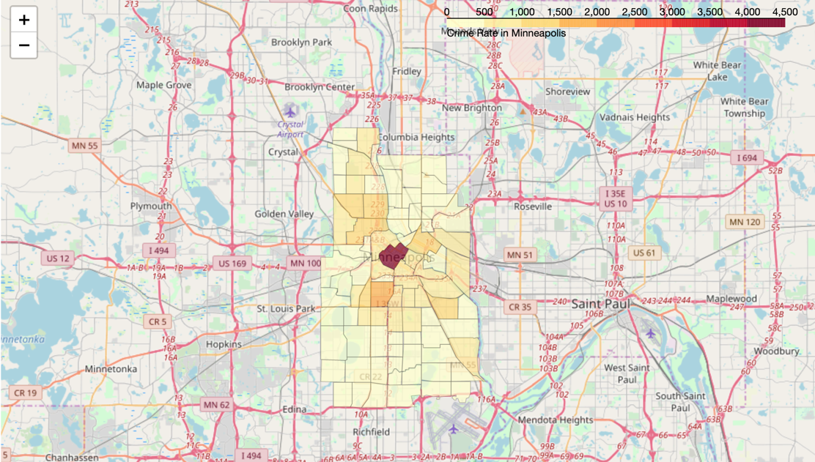

2.4 Crunching the Numbers

Now I was ready to do my analysis on a neighborhood by neighborhood basis. Due to residential zoning, I determined the optimal distance of our shop from competitors was 2 neighborhoods, not distance “as the crow flies.” This is because using straight distance resulted in areas where commercial enterprises were not allowed. By using the “2 neighborhoods” metric, I was able to target commercial areas. This feature was non-negotiable, so I was able to cull the list from 83 to 18 potential neighborhoods.

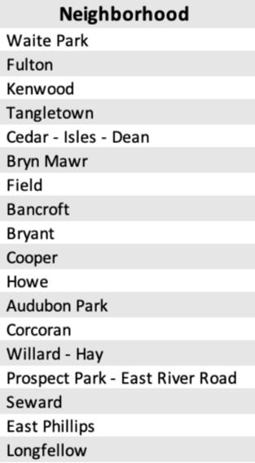

I then determined the population and crime rates of these 18 neighborhoods. Crime rate was a simple matter of dividing population by number of crimes committed in each neighborhood.

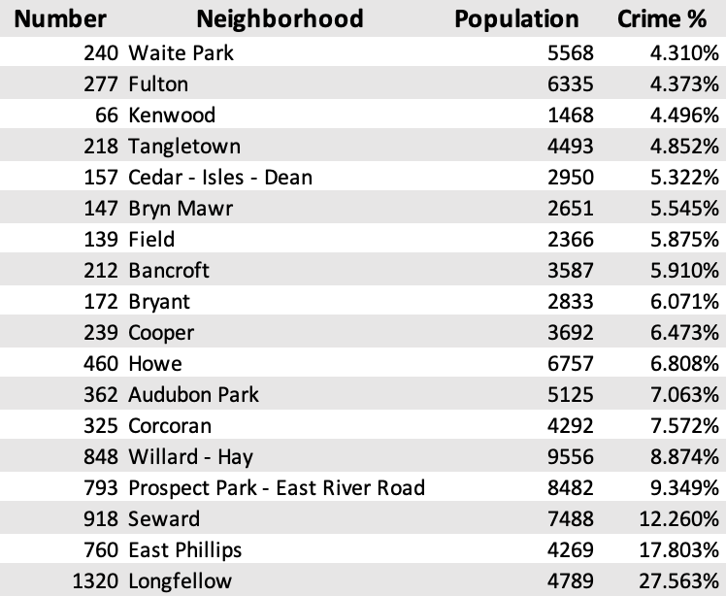

From here, I removed every neighborhood with fewer than 3,000 residents, and/or a crime rate higher than 6%. This reduced the list to four prime neighborhoods; however, one of them was removed immediately because it did not have a commercial center to put a shop, and thus was disqualified. I then took the median household income of the remaining 3 neighborhoods:

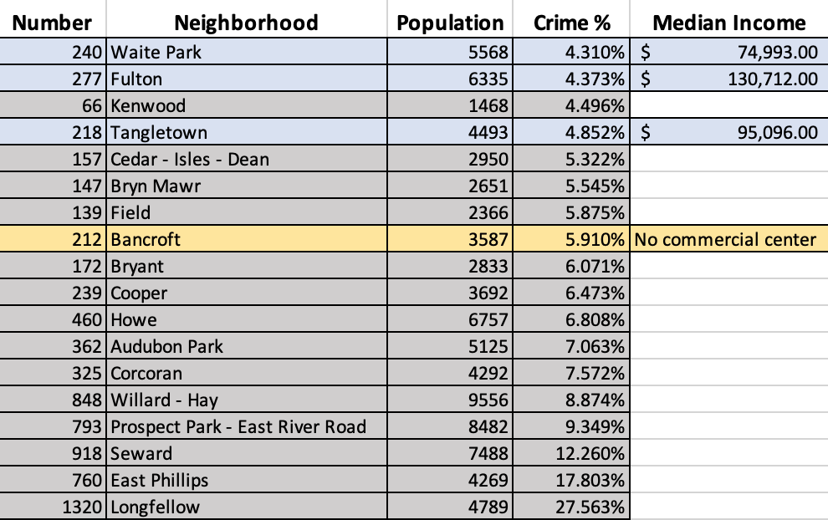

2.5 Data Normalization

I normalized the data for the 3 neighborhoods, and three critical factors, which gave me:

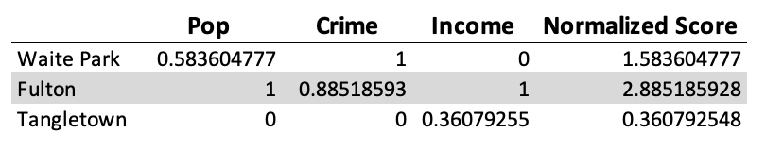

3. Results

3.1 Location

The clear winner was the Fulton Neighborhood, which is located in southwestern Minneapolis, abutting the suburb of Edina to the west. It met the initial critical requirement of being an optimal neighborhood distance from existing donut shops. In the final analysis it had the highest population and income scores, and a very low crime rate. I decided to place the donut shop in the highly respected and coveted location of 50th & France in the Fulton Neighborhood.

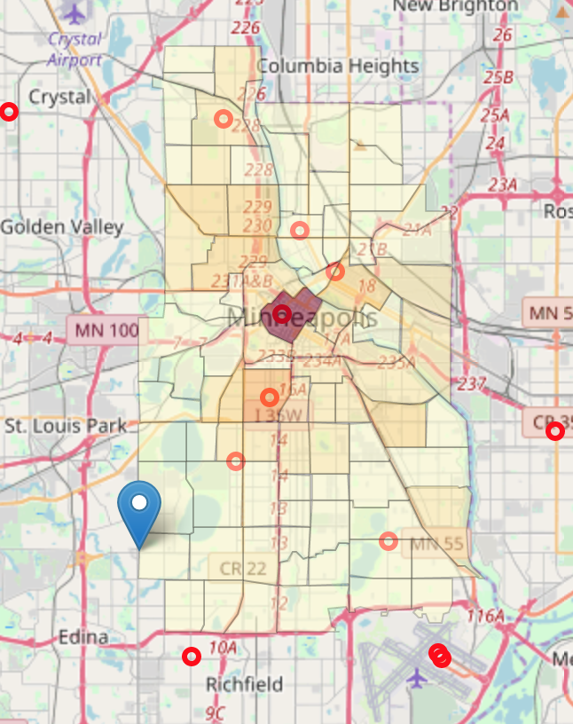

After I concluded my analysis, Galaxy Donuts broke ground, and the new location will be open soon!

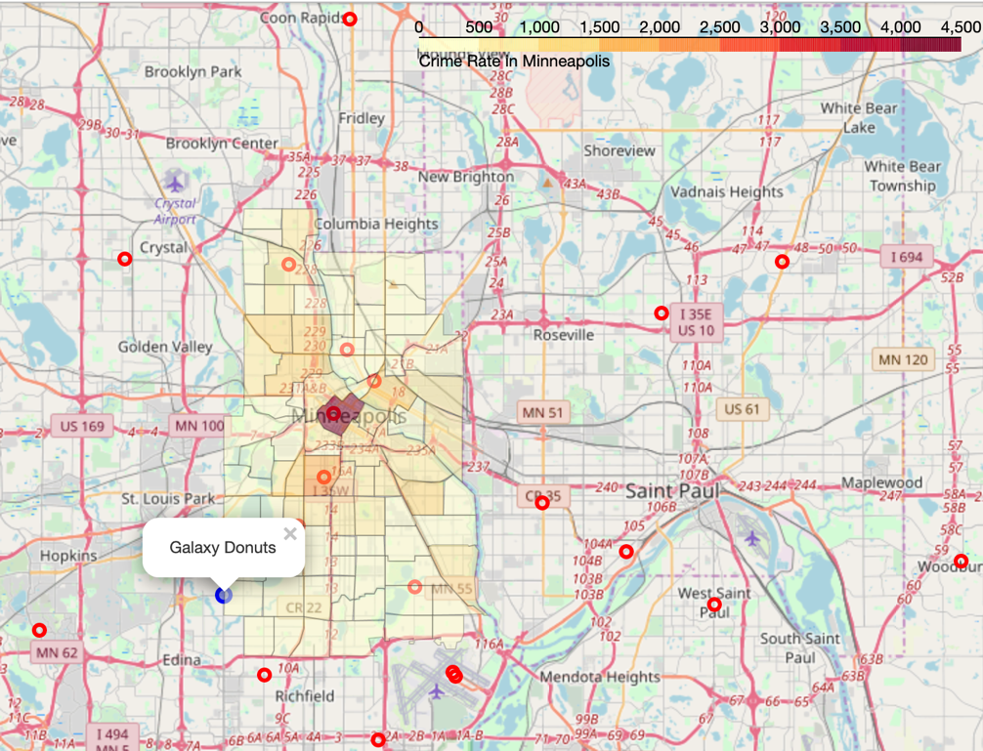

4. Discussion

4.1 Observations

My first observation is that analysis of geographical areas and demographics is extremely difficult and requires a strong knowledge of the area. For example, my initial hypothesis to place the location at the maximum distance from all existing donut competitors fell flat, because it kept returning areas that were impossible to open a donut shop (in either industrial or residential zones of the neighborhood). I immediately realized I needed to factor in commercial location distance, but also population density, income, and safety. My final analysis required many hours of trial and error, as I refined my hypothesis

4.2 Recommendations

If I were to expand my analysis, I would try to determine whether grocery stores that had full bakeries should be considered as competitors to a premium donut shop. I would also recommend a full analysis of coffee shop locations, and whether proximity would hurt or hinder our donut shop (because coffee sales comprise a portion of our revenue). However, I wonder if only premium coffee shops should be considered, or all coffee shops. This would require a lot of thinking, data analysis and model-tweaking. If I had more time and resources, I would also consider an analysis of first-ring and second-ring suburbs.

5. Conclusion

After much time, thought and analysis Galaxy Donuts decided to expand to the Fulton Neighborhood in southwest Minneapolis. This was a very important data-driven decision, based on distance from existing donut shops, population, safety, and median household income. Galaxy Donuts is excited about this expansion into Minnesota and hopes to forge a lifetime relationship with the citizens of Minneapolis.

**References**

§ Foursquare API to plot all Minneapolis donut shops

§ Neighborhood data:  
http: //opendata. minneapolismn. gov/datasets/minneapolis-neighborhoods

§ Crime data:  
http: //opendata. minneapolismn. gov/datasets/neighbor hood-crime-stats

§ Income data:  
https: //www. mncompass. org/profiles/neighborhoods/ minneapolis-saint-paul#!community-areas